**Parliamentary Election Based Algorithm**

# Parameters:-

Pn = 1000; (Total Population)

M = 10; (Parties)

Pm = 0.3; (Probability of Merging worst 2 parties)

Pd = 0.05; (Probability of deleting worst party)

Iterations = 10;

M = 0.58;

N = 0.23; (M and N are the fraction values used to determine party fitness)

Ƞ = 0.3 (factor during influencing population of parties)

# Result on Data Sets

## Karate Club:- (34 Nodes, 78 edges)

Best fitness value = 0.4042571

2nd Best fitness value = 0.3810815

3rd Best fitness value = 0.3692472

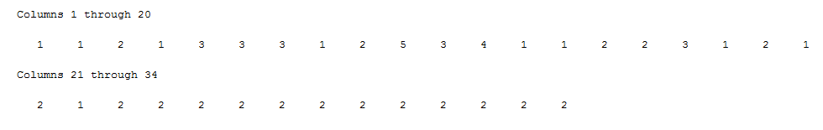

## Dolphin club:- (62 Nodes, 159 Edges)

Best fitness value = 0.4742099

2nd Best fitness value = 0.4705906

3rd Best fitness value = 0.4705906

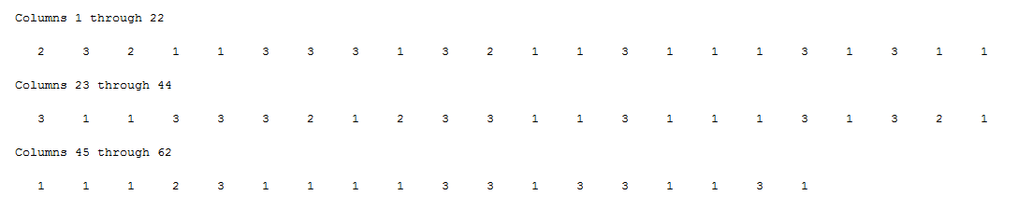

## American College Football (115 Nodes, 613 Edges)

Best fitness value = 0.4647510

2nd Best fitness value = 0.4627324

3rd Best fitness value = 0.4608669

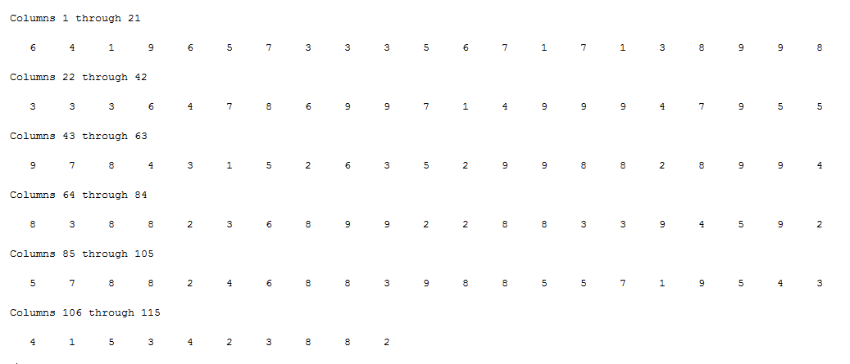

## Strike Dataset (24 nodes, 38 Edges)

Best fitness value = 0.5972992

2nd Best fitness value = 0.5972992

3rd Best fitness value = 0.5972992

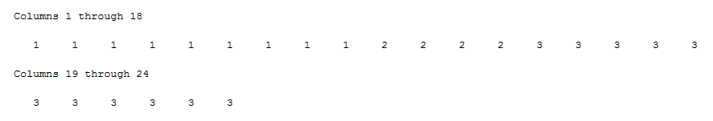

## Jazz Musician (198 Nodes, 2742 Edges)

Best fitness value = 0.4002850

2nd Best fitness value = 0.3861308

3rd Best fitness value = 0.3761156

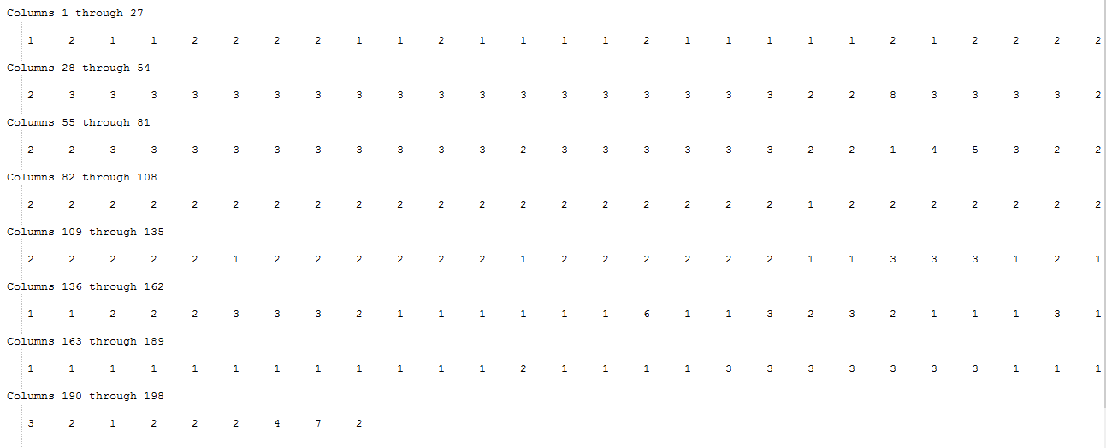

## Books on US Politics (105 Nodes, 441 Edges)

Best fitness value = 0.4939737

2nd Best fitness value = 0.4855230

3rd Best fitness value = 0.4764296

